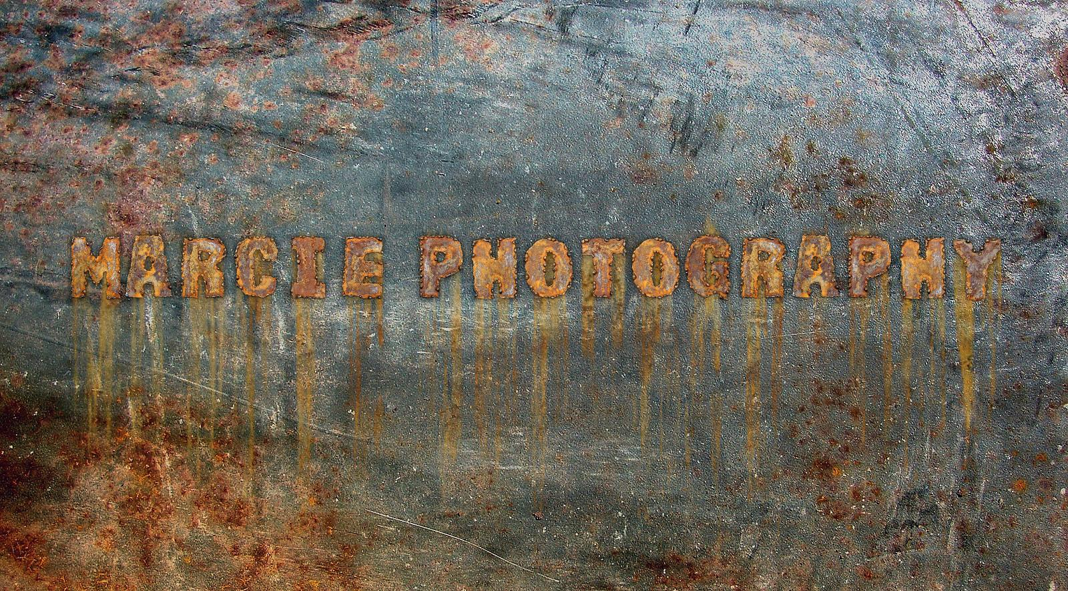

Contact Info -
MARCIEDELAPAZ@YAHOO.COMWWW.FACEBOOK.COM/MARCIESTUDIOS
INSTAGRAM : MARCIE_PHOTOGRAPHY
MARCIEDELAPAZ.WIX.COM/MARCIE-PHOTOGRAPHY
347-422-4056

Rates

Description Cost Notes
Shooting
(per hour) $175 Includes all digital post-processing, airbrushing, touchups, etc.

Studio time/rental - 2 hrs minimum 130.00 / THIS IS NONREFUNDABLE ONCE CONFIRMED
For groups/children/events/ family photo shoots are $400 for a 3 hour shoot. Anything above the time frame will be additional. Viewing of some Images prior to editing. Total 30 fully edited Images for portraits. Total - Large groups/events will be 100 edited images. All on a CD to view/download and print online.
Price list available for photo packages.

50% of payment Is due a week prior to scheduling for shoot or full payment
On day of the shoot. Payment must be received before shoot begins.
Cash/Check or Money order is accepted.

If you need to cancel /reschedule for any reason please advise 1 week prior to shoot.
Once studio space Is confirmed and you reschedule another deposit will be charged.

Thank you for choosing Marcie Photography for your choice of lifetime photographs.

